**Graduate Projects**

University of Colorado at Boulder

Aerospace Engineering Sciences

ASEN 5018/6028 –Fall 2015

|  |
| --- |
| **FlyNet**  **Vehicle Subsystem Summary/Continuity Document** |

|  |  |  |
| --- | --- | --- |
| **Approvers List** | | |
|  | Title | Name |
| Prepared By | Vehicle Team | Tyler Clayton |
|  |  |  |
| Approved By | Vehicle Lead | Tyler Clayton |
| Approved By | Systems Engineer |  |
| Approved By | Project Manager | Drew Ellison |

**1: Introduction & Summary**

The purpose of the Vehicle Subsystem is to provide a platform to carry all sensors, computers, and power in order to perform autonomous search and rescue in an unfamiliar indoor environment. All of these components must be selected and secured onto the platform for safe and reliable flight.

The Vehicle Subsystem is based around the AlienCopter Bee 430mm quadcopter frame. This serves as the platform to carry the battery and all of the electronics needed to perform the mission. Thrust will be provided to the system through the use of 4 SunnySky X2212 KV980 II brushless motors. A 4S 10000mAh Multistar LiPo Battery pack is used to provide power to the entire system and is distributed through a HK Pilot VI power distribution board. Custom blade guards created from carbon fiber rods and a hula-hoop were constructed as well as landing gear from plastic piping.

# **2: Semester Report**

## 2.1: Objectives and Tasks List

**Completed**:

1. Select and construct quadcopter frame
2. Determine total mass budget
3. Determine total power budget and estimate flight durations
4. Select adequate motors based on mass budget
5. Determine how power will be distributed throughout the system
6. Construct Blade guards
7. Construct landing gear
8. Proof of Manual Flight using Radio Controller

**Incomplete**:

1. Complete interface between Guidance sensor and quadcopter frame
2. Build mount for FLiR camera and install to quadcopter
3. Flight duration experiments with completed system
4. Build another system for team flight & exploration
5. Integrate additional payload and possible dropping mechanism to the quadcopter
6. Develop ground robots as a testing platform for perception and planning subsystems

## 2.2: Issues

What problems prevented you from being able to complete the tasks above?

1. Development with the FLiR camera is ongoing. To avoid possible damage to the sensor it has not been integrated on to the quadcopter frame.
2. Development with the Guidance sensor is ongoing and has run into some issues (See Perception Subsystem Summary). For ease of use of the sensor during development of the SLAM (Simultaneous Localization and Mapping) algorithms and to avoid sensor damage it was left off of the quadcopter frame.
3. Flight duration testing was performed with old motors that were deemed insufficient for the final system. Due to time constraints and needing the vehicle for controls and autopilot testing additional duration testing was not performed.
4. Due to time constraints and more pressing objectives the Fall 2015 semester focused on getting one quadcopter system up and running. Team flight and operations is going to be focused on in the Spring 2016 semester.

## 2.3: Lessons Learned

1. Make sure to update technical budgets as items change and be familiar on what other subsystems are working on so that items are current and up to date.
2. Make sure to have predefined checklists before testing to check for missing/broken parts and abnormalities in sound, software, etc. This can help to avoid future damages
3. Extra components are good to have around when something breaks, because something will go wrong and need to be replaced.

## 2.4: Procedure:

This section details the specifics on what the Vehicle Subsystem accomplished this semester. It has been broken down into separate subsections for the specific tasks.

**NOTE:** All file destinations are found in the FlyNet github directory found at:

* ***github.com/dme722/FlyNet***

### 2.4.1: QuadCopter Frame Selection

The quadcopter frame is essential to the overall FlyNet system. Without autonomous flight for search and rescue would not be possible. The frame, shown in Figure 1, was initially given to the FlyNet team from RECUV. Based on the need to fly through standard 36 inch doors and the need to carry necessary hardware it, this frame was deemed acceptable. It provides a 430 mm wheelbase, which once blade guards are installed (see section 2.4.5), allows the quadcopter to fly through the required door frame width. Note that at this time the quadcopter has only been flown through the 36 inch door frame manually and not autonomously. The AlienCopter Bee frame also has three different decks, which provides room for the necessary sensors to all fit on the frame.

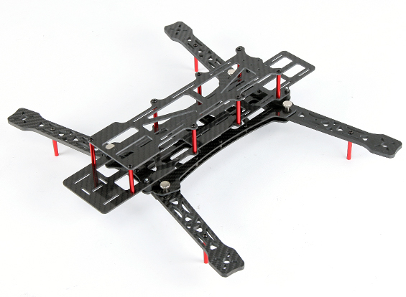

Figure : AlienCopter Bee Quadcopter Frame

This quadcopter frame can be found at the following link:

<http://www.hobbyking.com/hobbyking/store/__61487__AlienCopter_Bee_full_Carbon_KIT_W_Clean_and_Dirty_System_and_PDB_W_BEC.html>

### 2.4.2: Mass Budget

The mass budget was created to keep track of all the components relating to the vehicle. This includes batteries, electronics, motors, and the quadcopter structure. Knowing the mass of the system helps in the motor selection (Section 2.4.3) and flight duration calculations (Section 2.4.6). The mass budget was created in an Excel spreadsheet and can be found here:

* **> Technical > Technical Budgets > PowerMassBOM_ABee_NEW.xlsx**

Note that this contains both the mass and power budgets for the FlyNet system. The spreadsheet has been made so items can easily be added and removed to see how it affects the system mass, power consumption, and flight duration. The budget is up to date with all the necessary hardware determined to be needed as of the end of the Fall 2015 semester.

### 2.4.3: Propulsion System Selection

The initial quadcopter system provided by RECUV already had a propulsion system installed. This was the E300 tuned propulsion system from DJI. However, after updates to the mass budget it was determined that this propulsion system would provide insufficient thrust. Ideally standard quadcopters, those which do not need excess thrust for aerobatic movements, should be able to provide double its weight in thrust. This allows the quadcopter to hover around 50% of the motor output. Note because of this requirement it is common to refer to the motor thrust in terms of grams and not the actual force. The force can be calculated simply by multiplying by the acceleration of gravity.

From the mass budget it was determined that the entire system would weigh around 2400 grams. This means the motors should output close to 4800 grams of total thrust or 1200 grams per motor. However, the E300 systems specifications noted that its maximum thrust output was 600 grams. This is less than half the necessary thrust meaning that the quadcopter when fully loaded will not even be able to take off; it only has enough force to hover. This prompted the need for new motors. Due to the availability of legacy hardware from the Drones Vs. Zombies graduate project motors were taken from the 3DR X8+ platform. These SunnySky X2212 KV980 II brushless motors provide a maximum thrust over 1210 grams while using a 10x3.8 style propeller. As these proved to be adequate for the FlyNet quadcopter the motors were salvaged from the legacy X8+ platforms. Information on the motors can be found in the following places:

* **> Technical > Technical Budgets**
* <http://www.buddyrc.com/sunnysky-v2216-12-800kv-ii-brushless-motor.html>

### 2.4.4: Power System Design

The power system was split up into two different categories. Firstly, how all the components were physically connected and powered and secondly the actual power budget calculations of the FlyNet system.

#### 2.4.4.1: Power Distribution

Due to the fact that the quadcopter had to be completely autonomous, it needed to carry its own source of power. This is done in the form of a 4S LiPo battery. However, not all of the components can run at the nominal 14.8 Volts supplied by the battery. A diagram of the power distribution can be found at:

* **> Presentations > frew_approved_block_diagrams.ppt**

The main supply line is split into three different directions. The first goes directly to the Guidance sensor, the second to a 5 Volt regulator which powers the ODROID, and lastly to a separate power distribution board (found at the following link).

* <http://hobbyking.com/hobbyking/store/__68694__HK_Pilot_Power_VI_Module_Distribution_Board_And_Dual_UBEC_ALL_In_One_120A_and_10s_.html>

This board supplies power to the Pixhawk at 5 Volts as well as allows all four motors/ESCs to connect to the battery.

#### 2.4.4.2: Power Budget

As stated in Section 2.4.3 the power budget is provided in the same Excel file as the mass budget. This is found at:

* **> Technical > Technical Budgets > PowerMassBOM_ABee_NEW.xlsx**

Voltage, current, and power were determined for each component that was necessary to the FlyNet system. Although the power draw is important, it is also important to look at the current draw this will give an estimation on the actual flight duration of the quadcopter. Using this information a battery could also be chosen. As mentioned a 4S LiPo battery was chosen as the power supply to the system. Specifically a 10000mAh Multistar battery pack is currently in use. Again this battery was salvaged from previous projects. Originally a 4500mAh battery was being used but after duration calculations it was determined that it would not be able to meet the minimum 10 minute flight duration requirement given all of the electronics in use. Given current estimation, the FlyNet quadcopter should be able to hover for around 22 minutes given a 0.5 pound additional payload. As mentioned previously actual experimental duration testing has not been completed using the new quadcopter configuration. Additional calculations and Matlab files can be found here:

* **> Technical > Technical Budgets**

### 2.4.5: Construction of Custom Landing Gear and Blade Guards

The AlienCopter Bee frame provided by RECUV did not come with any blade guards. For safety reasons and to help the quadcopter be able to travel through doorways easier new blade guards were designed as shown in Figure 2. The blade guards were created by slicing a hula-hoop into three equal pieces. This left one piece as a backup if necessary. Carbon fiber rods were hot glued together and screwed into the motor base. Holes were then drilled into the hula-hoop pieces were the rods would intersect with the hula-hoop.

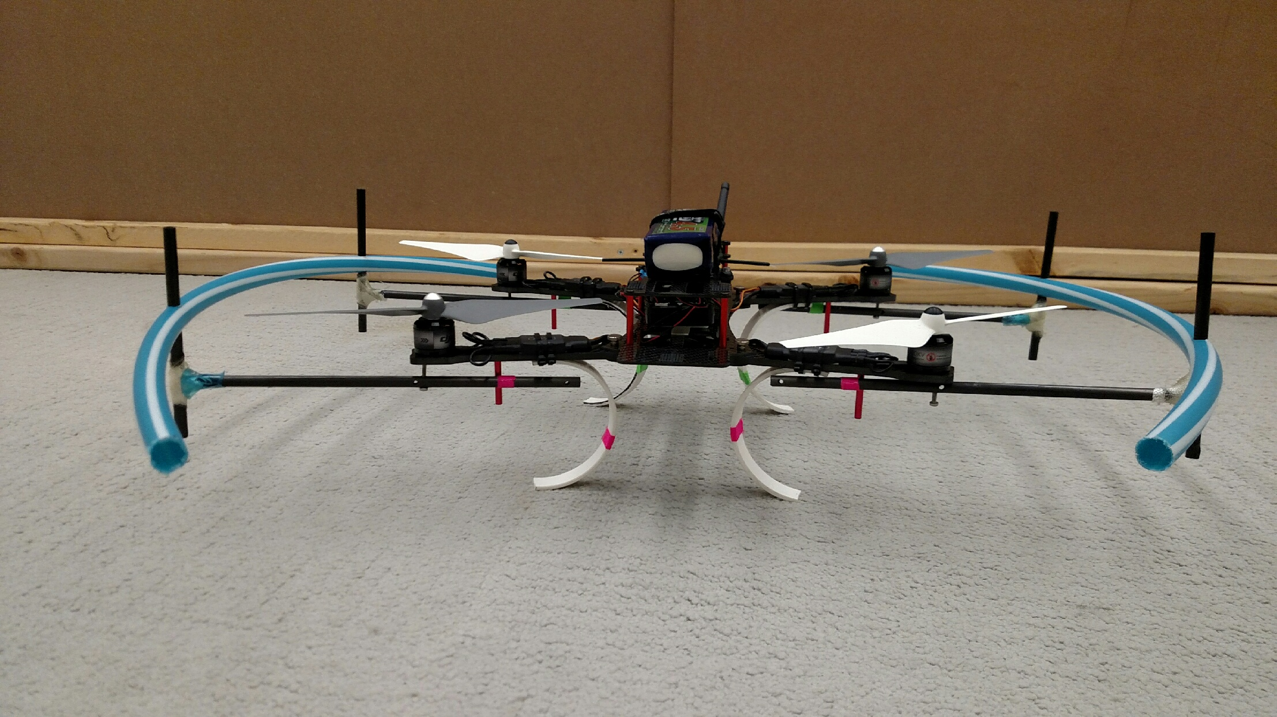

Figure : AlienCopter Bee with Custom Landing Gear and Blade Guards

The landing gear were created off inspiration from the following video:

* <https://www.youtube.com/watch?v=wxoLY_l2oX0>

Plastic tubing (3 inch diameter) was used and cut in 1 inch thick circular slices. Each slice was cut in half and zip ties were used to attach the gear to the arms of the quadcopter. Using landing gear like these provided a spring like response to the quadcopter helping to cushion less than soft landings. These also keep the structure of the quadcopter further off the ground which will be necessary when the Guidance sensor is integrated to the bottom of the quadcopter frame.

# **3: Next Semester/Future Expectations**

## 3.1: Prioritized List of Tasks and Objectives

Here are tasks suggested to familiarize or re-familiarize yourself with the Vehicle Subsystem.

1. Review other subsystem documentation and talk to team leads in order to understand how all the components are intended to interact with each other. Especially be familiar with known issues that have not been addressed or completed
2. Review diagrams on how each component is connected to each other on the quadcopter
3. Integrate FLiR camera and Guidance sensor onto the AlienCopter Bee frame
4. Be prepared. Have additional hardware available and be familiar with its integration onto the quadcopter. When testing is performed, especially autonomous testing, things are likely to break. Have backups and being familiar with complete system integration will minimize time lost due to system damage.
5. Perform flight duration testing to achieve actual performance of the system

## 3.2: Starting Points

For each one of the tasks and objectives in 3.1, it is suggested to start here:

1. Begin be reading through the continuity documents found at:

* **> Technical > documentation > Fall2015FinalReports > Continuity Documents**

It may also be helpful to review the end of semester CDR slides which can be found at:

* **> Presentaions > CDR_Fall_2015**

1. Refer to the CDR presentation at the above location or to the technical documentation found at:

* **> Technical > documentation > Fall2015FinalReports > Technical Documents**

1. Refer to CDR and technical documents on how all the components should be connected. Look at the specific sensor specification and user guides found on the Sparkfun and DJI product websites.
2. Keep track of all necessary inventories. All parts that are not used should be moved to a location so as not to confuse with needed parts. If pieces are missing order new or construct new/backups. Specifically at least one additional pair of landing gear should be ready and two sets of spare propellers should be available.
3. Flight duration testing should be performed on a completed system. If confidence is not with the human pilot or the current condition of the autopilot is still shaky remove expensive hardware from the quadcopter. This includes the Guidance sensor and FLiR camera. Add mass using the copper pellets found in the RECUV lab to simulate the mass of these sensors. Ideally this test should be performed autonomously to get the most realistic results possible. Using the Vicon tracking system in the loop is a good place to start.

## 3.3: Improvement, Updates, Verification

1. As the development of each of the sensors and their integration with each other is updated and improved it may be necessary to change the technical budgets. Note that if any sensor proves to be inadequate and is switch for another this should be updated in both the power and mass budgets. In turn this could result in a redesign or replacement/relocation of items on the quadcopter structure.